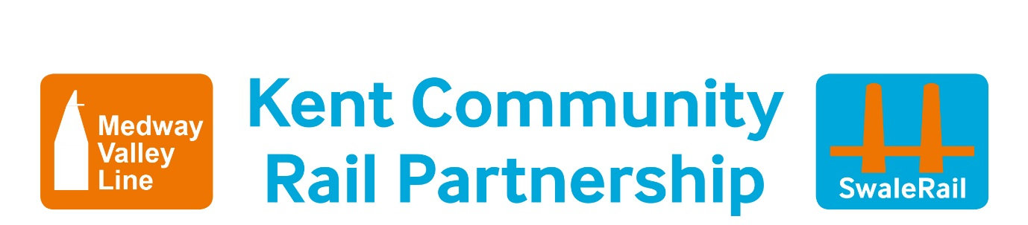**KS**

**Smarter Travel Challenge**

**Aims:**

To enable pupils to make smarter choices about how they travel to secondary school, that consider their health and the environment.

**Learning Objectives: knowledge, understanding, skills, values**

* To find out how pupils already travel (survey)
* To investigate ways that pupils can travel to school
* To understand why it is important to travel in ways that are good for your health and the environment
* To use paper based timetables to find information about a journey
* To use the internet, particularly the world wide web using journey planner websites, Kent Connected, Traveline, Google maps, Cyclestreets, National Rail Enquiries, Southeastern apps.
* To create own plan on how they will travel to secondary school.

**National Curriculum Links**

**2 Geographical skills & fieldwork KS2 Y6**

**e** Use fieldwork to observe, measure, record & present the human and physical features in the local area using a range of methods including sketch maps, plans, graphs and digital technologies

**4 Mathematics Statistics KS2 Y5**

**e** Complete, read and interpret information in table, including timetables

**Computing KS2 Y6**

**c** Understand computer networks, including the internet, such as the world wide web.

Use technology safely, responsibly and respectfully

**1 Science Animals including humans KS2 Y6**

**b** Recognise impact of diet, exercise, drugs and lifestyle on the way their bodies function.

**Resources**

I want to travel by train leaflet

School Travel Guide

Class set of train timetables

Map of your journey (blank)

|  |  |  |
| --- | --- | --- |
| Activity Time | Activity Details | Resources |
| 5 | **Welcome and Introductions**  Im here to talk to you today about how you could travel to this school/to secondary school |  |
| 5 | **How could you travel in ways that are good for your health and the environment to this school?**  Brainstorm ideas, including walk, cycle, bus, train, **NOT car** | Flipchart/ White board and pen |
| 20 | **How will you Travel to school?**  **Use Journey planning websites to plan your journey to this school**  <https://kentconnected.org/year-6-travel>  [www.cyclestreets.net](http://www.cyclestreets.net)  [www.11-19travel.info](http://www.11-19travel.info)  [www.southeasternrailway.co.uk](http://www.southeasternrailway.co.uk)  [www.nationalrail.co.uk](http://www.nationalrail.co.uk)    **The Smarter Journey Challenge –Map your Journey to school**  **Go to Kent Connected.**  Type your address on top line.  Type school name on bottom line.  Click on Find Routes. Note heart icon = calories used and leaf icon = pollution %  **Can you choose routes that are good for your health and environment?**  Complete Map your Journey including yellow sections. | Copy of Smarter Travel Challenge – Map your Journey (one per pupil)  And one pencil each |
| 10 | **Complete the Hands Up Survey to find out how pupils will be travelling to school** | Hands Up Survey |
| EARLY FINISHERS | **Complete the Green Tweet** | Copy of Green Quiz Sheet |
|  | **PLENARY**  **Thanks, Good Luck and see you September!**  **Hand out I want to travel by Train leaflet & School Travel Guide** | I want to travel by Train leaflet  School Travel Guide |

an **2 hours (**