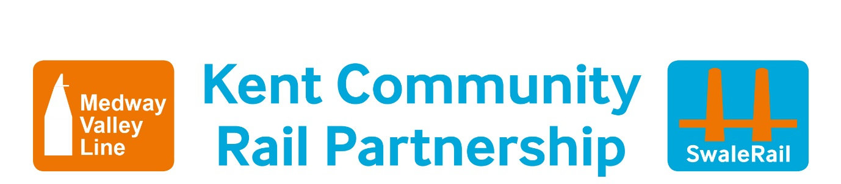

**Hands Up Survey Smarter Travel Challenge**

|  |  |
| --- | --- |
| **Date:** | **School Name:** |
| **No of Pupils:** | |

|  |  |
| --- | --- |
| **Q1 How did you get here today?** | |
| **Response** | **Count** |
| Cycle |  |
| Walk |  |
| Scoot/Skate |  |
| Park and stride/park and cycle |  |
| Bus |  |
| Train |  |
| Car |  |
| Other |  |

|  |  |
| --- | --- |
| **Q2 How do you usually get to primary school?** | |
| **Response** | **Count** |
| Cycle |  |
| Walk |  |
| Scoot/Skate |  |
| Park and stride/park and cycle |  |
| Bus |  |
| Train |  |
| Car |  |
| Other |  |

|  |  |
| --- | --- |
| **Q3 How do you plan to come to secondary school?** | |
| **Response** | **Count** |
| Cycle |  |
| Walk |  |
| Scoot/Skate |  |
| Park and stride/park and cycle |  |
| Bus |  |
| Train |  |
| Car |  |
| Other |  |

|  |  |
| --- | --- |
| **Q4 How many of you have done your cycle training – bikeability?** | |
| **Response** | **Count** |
| Yes |  |
| No |  |
|  |  |