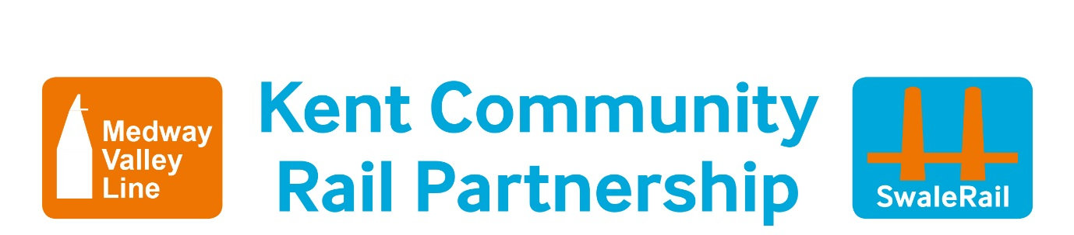

**Hands Up Survey Post Smarter Travel Challenge**

|  |  |
| --- | --- |
| **Date:** | **School Name:** |
| **No of Pupils:** | |

|  |  |
| --- | --- |
| **Q1 How did you get here today?** | |
| **Response** | **Count** |
| Cycle |  |
| Walk |  |
| Scoot/Skate |  |
| Park and stride/park and cycle |  |
| Bus |  |
| Train |  |
| Car |  |
| Other |  |

|  |  |
| --- | --- |
| **Q2 How do you usually get to secondary school?** | |
| **Response** | **Count** |
| Cycle |  |
| Walk |  |
| Scoot/Skate |  |
| Park and stride/park and cycle |  |
| Bus |  |
| Train |  |
| Car |  |
| Other |  |

|  |  |
| --- | --- |
| **Q3 Did you use the Kent Connected website over the summer?** | |
| **Response** | **Count** |
| Yes |  |
| No |  |
|  |  |

|  |  |
| --- | --- |
| **Q4 Did you access any timetables to ensure no changes had been made?** | |
| **Response** | **Count** |
| Yes |  |
| No |  |
|  |  |

|  |  |
| --- | --- |
| **Q5 Did you actually come secondary school in the way you wanted to?** | |
| **Response** | **Count** |
| Yes |  |
| No |  |
|  |  |

|  |  |
| --- | --- |
| **Q6 Have you downloaded on a mobile phone any apps such as Arriva bus app, Southeastern app, Traveline app, National Rail enquiries app, cyclestreets app** | |
| **Response** | **Count** |
| Yes |  |
| No |  |
|  |  |

|  |  |
| --- | --- |
| **Q7 Have you put the British Transport Police text number on your mobile? 61016** | |
| **Response** | **Count** |
| Yes |  |
| No |  |
|  |  |

|  |  |
| --- | --- |
| **Q8 Have you put the ICE – in case of emergency contact details on your mobile?** | |
| **Response** | **Count** |
| Yes |  |
| No |  |
|  |  |